Sri Sai Anusha Gandu, Student ID: 16230560

Assignment 1

Network Architecture-I, Fall-2016

**1.** Suppose two hosts, A and B are separated by 40,000 kilometers and are connected by a direct link of R=1 Mbps. Suppose the propagation speed over the link is 2*108 meters/sec. Consider sending a file of 4,000,000 bits from Host A to Host B.

**a.** Suppose the file is sent continuously as one big message. How long does it take to send the file, assuming it is sent continuously?

**Ans:**

Given,

Distance between Host A and Host B (D) = 40,000 kilometers = 4*107 meters

Link Bandwidth (R) = 1 Mbps = 106 bps

Propagation Speed (S) = 2*108 meters/sec

Packet Length (L) = 4,000,000 bits = 4*106 bits

The file is sent as a single message

Time taken to send the file is the sum of processing delay, queuing delay, transmission delay and propagation delay

T = tproc + tqueu + ttrans + tprop

Since the message sent is a single message and through direct link,

Queuing delay tqueu = 0 and

Processing delay tproc = 0

Transmission delay ttrans = L/R

= 4*106/106

= 4 sec

Propagation delay tprop = D/S

= 4*107/2*108

= 0.2 sec

Total time taken T = 4+0.2

= 4.2 sec

**T = 4.2 seconds**

**b.** Suppose now the file is broken up into 1000 packets with each packet containing 4,000 bits. Suppose that each packet is acknowledged by the receiver and the transmission time of an acknowledgement packet is negligible. Finally, assume that the sender cannot send a packet until the preceding one is acknowledged. How long does it take to send the file?

**Ans:**

Given,

Distance between Host A and Host B (D) = 40,000 kilometers = 4*107 meters

Link Bandwidth (R) = 1 Mbps = 106 bps

Propagation Speed (S) = 2*108 meters/sec

Length of each packet (L) = 4000 bits

No. of packets = 1000

Since the message sent is a single message and through direct link,

Queuing delay tqueu = 0 and

Processing delay tproc = 0

Time taken to send the file is the sum of transmission delay at the Tx, transmission delay at the Rx propagation delay at the Tx and propagation delay at the Rx

T = ttrans (Tx) + ttrans (Rx) + tprop (Tx) + tprop (Rx)

The transmission time of acknowledgement packet is 0

ttrans (Rx) = 0

Transmission time ttrans (Tx) = L/R

= 4000/106

= 0.004 sec

Propagation delay tprop (Tx) = D/S

= 4*107/2*108

= 0.2 sec

Propagation delay tprop (Rx) = D/S

= 4*107/2*108

= 0.2 sec

Time taken for each packet = 0.004+0.2+0.2 = 0.404 sec

Time taken for 1000 packets = 1000*0.404 = 404 sec

**T = 404 seconds**

**c.** Calculate the bandwidth-delay product, R*tprop. What does it mean? (Provide an interpretation of the bandwidth-delay product.)

**Ans:**

Bandwidth delay product = R*tprop

= (106)*(0.2)

= 2*105 bits

**R*tprop = 2*105 bits**

**d.** If there are two routers between Host A and B (rather than a direct link), and all three links have 1 Mbps links, how long does it take to send the file? (use the assumptions in 1b)

**Ans:**

Given the no. of routers between A and B = 2

Hence, there will be 3 links between A and B i.e., (A to R1), (R1 to R2), (R2 to B)

Hence, the total transmission delay will be 3 times (L/R)

Since the message sent is a single message,

Queuing delay tqueu = 0 and

Processing delay tproc = 0

Time taken to send the file is the sum of transmission delay at the Tx, transmission delay at the Rx propagation delay at the Tx and propagation delay at the Rx

T = ttrans (Tx) + ttrans (Rx) + tprop (Tx) + tprop (Rx)

The transmission time of acknowledgement packet is 0

ttrans (Rx) = 0

Transmission time ttrans (Tx) = 3*(L/R)

= 3*(4000/106)

= 3*(0.004)

= 0.012 sec

Propagation delay tprop (Tx) = D/S

= 4*107/2*108

= 0.2 sec

Propagation delay tprop (Rx) = D/S

= 4*107/2*108

= 0.2 sec

Time taken for each packet = 0.012+0.2+0.2 = 0.412 sec

Time taken for 1000 packets = 1000*0.412 = 412 sec

**T = 412 seconds**

**2.** Read articles on two Internet pioneers from http://www.ibiblio.org/pioneers/index.html, and write 1~2 paragraph(s) of your personal perspective (why you chose the person, what part of the story strikes/interests you, or what you learned from the story, etc.) on each person's story (thus 2~4 paragraphs total).

**Ans:**

**Vint Cerf:**

Vint Cerf is called the “Father of the Internet”. He was one of the co-authors of the TCP/IP protocol that allowed several independent networks to communicate with each other and they called this network of networks as INTERNET. He mastered from Stanford in 1965, worked for IBM as systems engineer and then returned to school to pursue his Ph.D. in computers.

He was one of the members of Network Working Group (NWG) which were into solving problems during the design and implementation of ARPANET. They released a protocol named Network Control Protocol (NCP) for host to host communication. He, along with Bob Kahn, described a new protocol called the Transmission Control Protocol (TCP), which encloses the packets in datagrams and transmits through gateway computer which does not care about the complexities of each network. They later split TCP into two parts. One called as Internet Protocol (IP), which is responsible for routing the packages. The other one still called TCP is responsible for dividing and reassembling the messages, detecting the errors, putting the packets in right order and resending the lost packets. This new protocol is called the TCP/IP protocol.

**Tim Berners-Lee:**

Tim Berners-Lee was the one who invented World Wide Web (WWW). He is an Englishman, graduated from Oxford in 1980 and landed in a temporary job at CERN as a software consultant. As CERN is a large international organization, to remember the connections between various people and projects at the lab, he wrote a program called Enquire, for his personal use. Later he left and returned with a permanent job at CERN in 1984 and found that his previous work with Enquire left a mental mark.

He envisioned a global information space where information stored on computers everywhere was linked and available to anyone anywhere. The two technologies that made his vision become reality are the Hypertext, which allows the reader to jump instantly from one electronic document to another and the Internet-the network of networks which uses TCP/IP protocol. He started work on the project and wrote Hypertext Transfer Protocol (HTTP), the language which the computers would use to communicate hypertext documents over the Internet with an address called Universal Resource Identifier (URI), also called Uniform Resource Locater (URL). He also wrote a client program which is used to retrieve and view hypertext documents and called this client as Worldwide Web.

**3.** Discuss on computer virus, worm, spyware, malware, Trojan horse, and botnet (1~5 sentences each).

**Ans:**

**Computer Virus:**

A computer virus is basically a malicious software program, often termed as “malware” created by humans, which when executed on a system replicates itself (its own source code) and infects the other computer programs by modifying them. When this replication gets succeeded, the affected areas are then said to be infected with a computer virus. This may perform including the access of private data, corruption of data and even causes a system failure. Antivirus software can be installed to prevent this type of damages.

**Worm:**

Worm, in computing termed as a computer worm, is a malware that replicates itself in order to spread to other systems. It is spread due to the security failures in the network. It doesn’t get attached to the program, but spreads over the systems. This might harm in a way such that the files get deleted in the host system and encryption of information.

**Spyware:**

Spyware is software that aims at collecting the information about a person or an organization without the knowledge of them. It is used for the purpose of tracking the movement of the Internet user. It can collect almost all types of data such as personal information, bank or credit details, etc. The result of spyware can change the computer settings and may cause decrease in the speed of the Internet. Running anti-spyware software can protect the system from hacked.

**Malware:**

Malware, short form of malicious software, defines the software that is generally used to harm the system. It can be used to gain the access over ones private system or display unwanted advertisements. Some types of malware get attached to the source code and affect the system and the other types of malware don’t get attached to the system code. Malware when present makes the system perform in a way that is not required by the user.

**Trojan horse:**

Trojan horse, or simply Trojan, is malicious software that doesn’t get injected into the files of the system. It is used to hack the system by misleading the users of its true intent. It allows the attacker to access personal information of the user including even IP address of the system.

**Botnet:**

The word botnet is a combination of two words: robot and network which is generally used with malicious connotation. It is a number of Internet connected devices communicating with other similar kind of devices which communicate and coordinate by Command and Control (C&C) by passing messages to one another. It compromises the computer which is breached which is known as “bot” and these are created when the computer is penetrated by a malware.

**4.** Explore ‘ping’ and ‘traceroute’ (or ‘tracert’ on Windows) which are basic tools used to measure network performance and retrieve network status. Run ‘ping’ and ‘traceroute’ with at least three different hosts and options. Record the commands and their output.

**Ans:**

**Ping:**

It is a software utility which is used to test the reachability of the host on an IP network. It is the measurement of the round trip time for the messages sent from the source to destination with the echo back to source.

ping –t command pings the specified host until stopped. To stop we use the command Ctrl+C

**ping –t google.com**

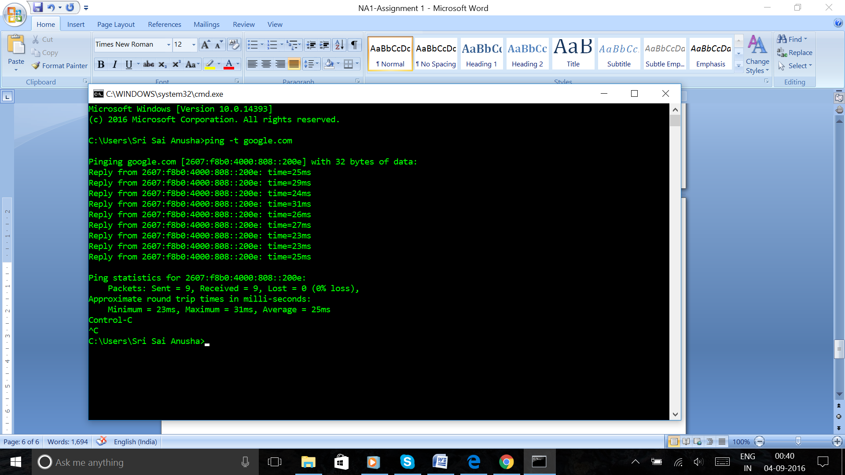

**ping –t youtube.com**

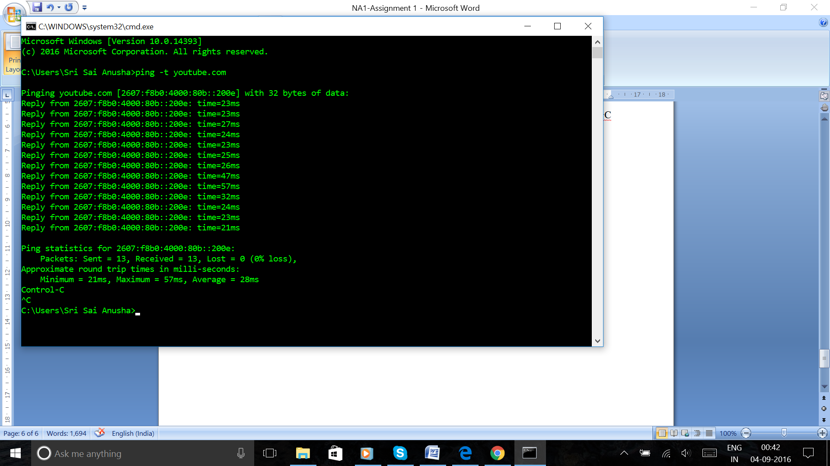

**ping –t gmail.com**

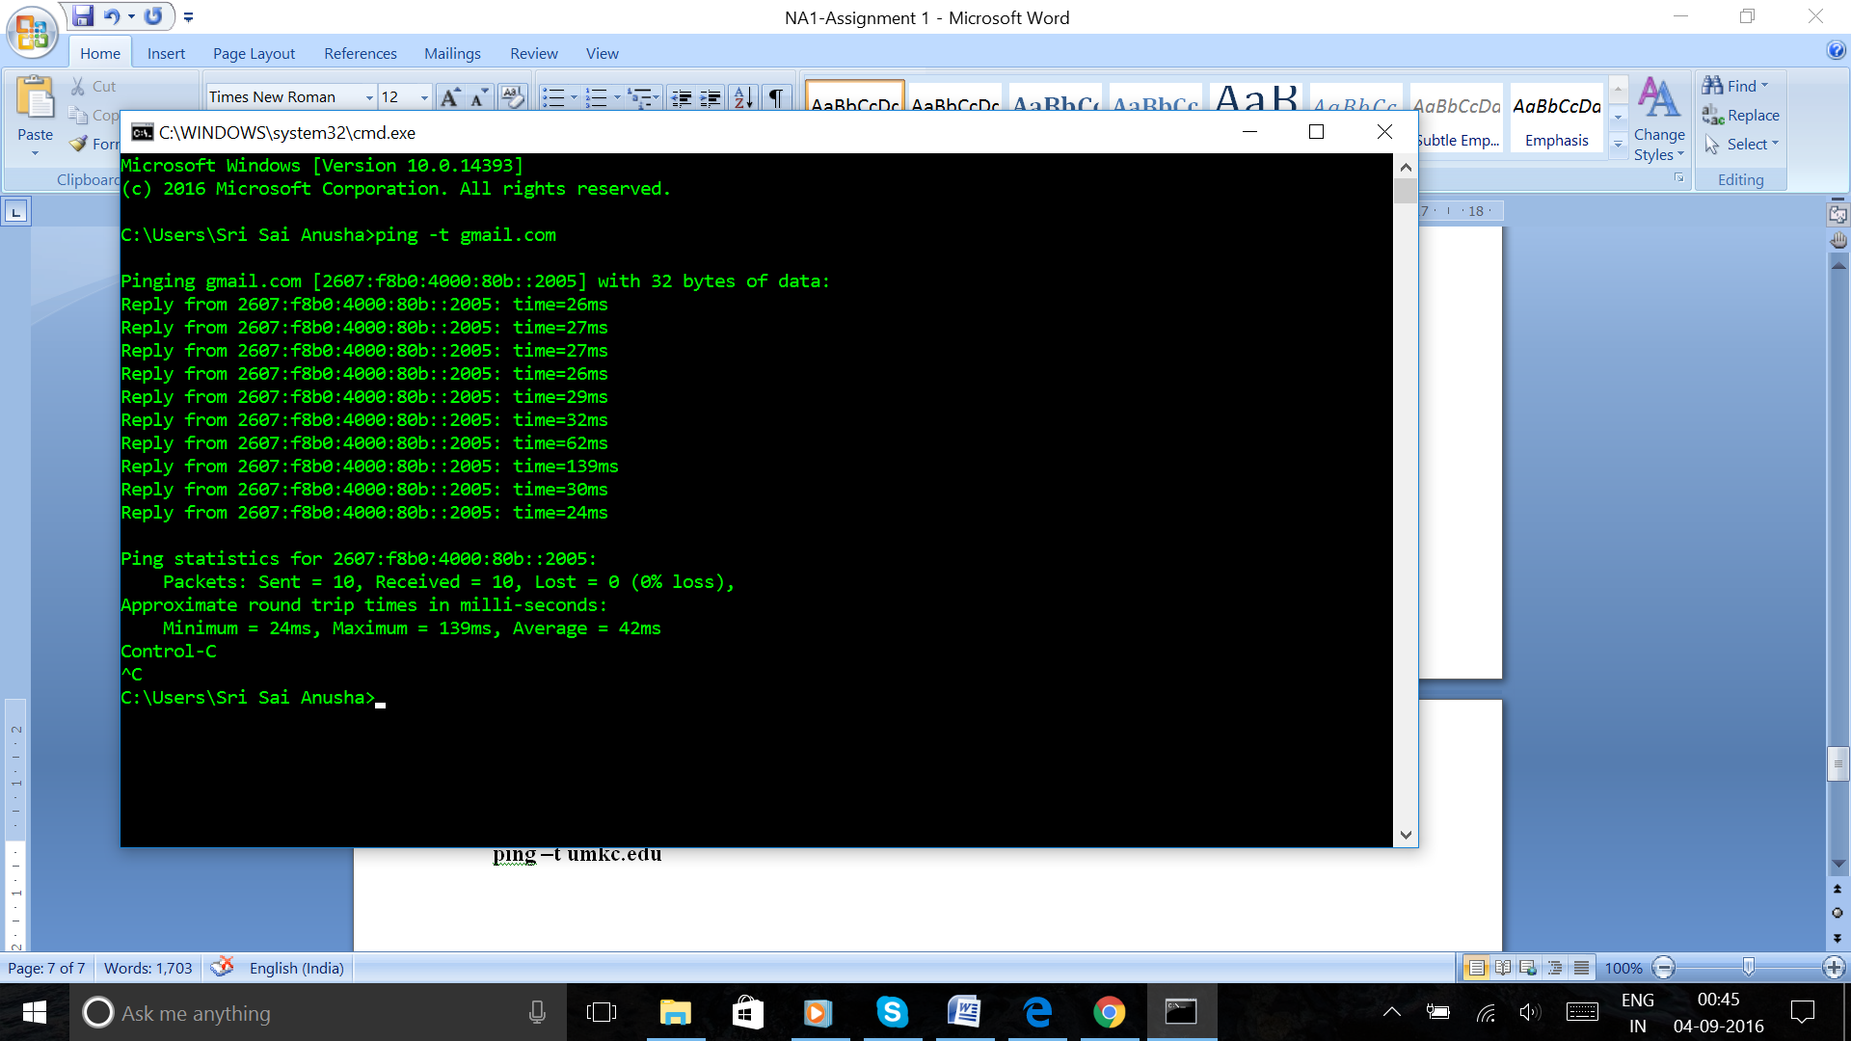

ping –l size command sends the buffer size in bytes

**ping –l 64 google.com**

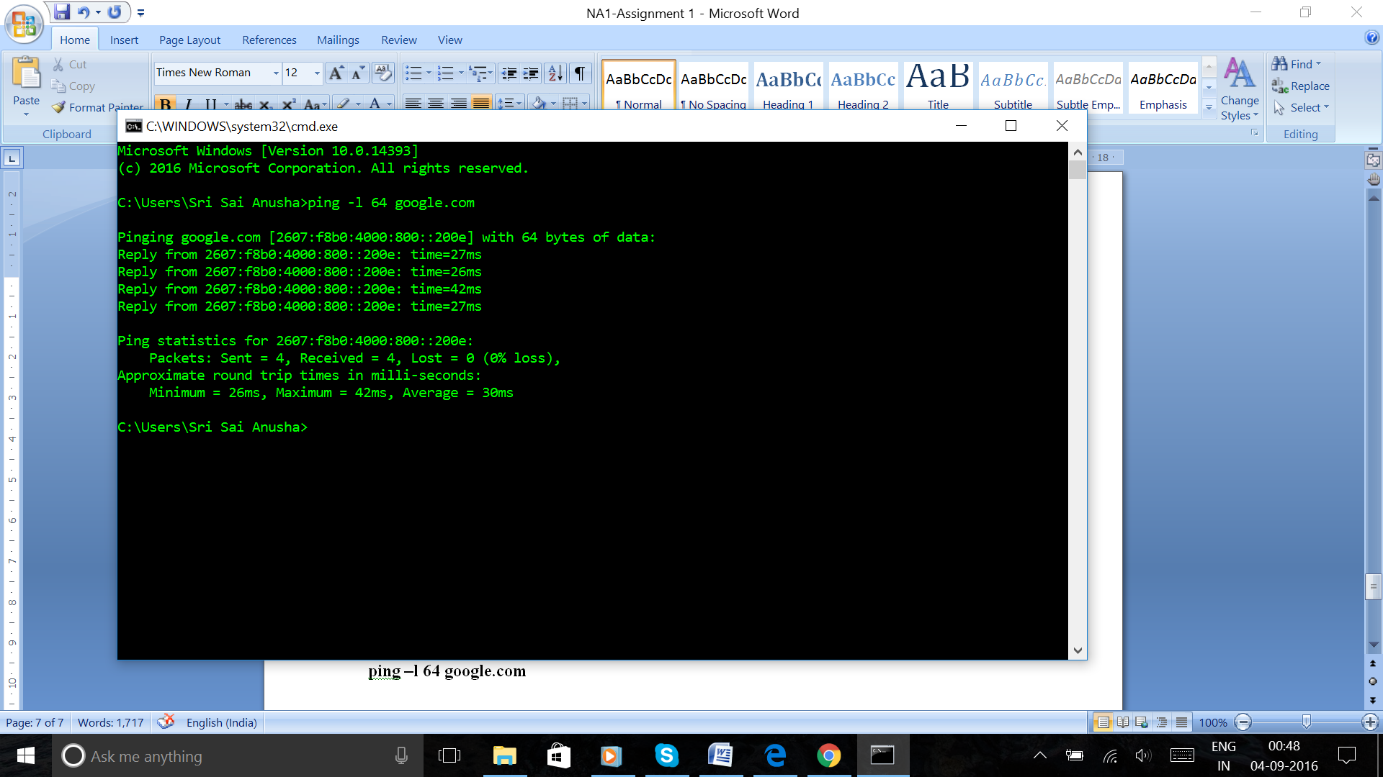

**ping –l 256 gmail.com**

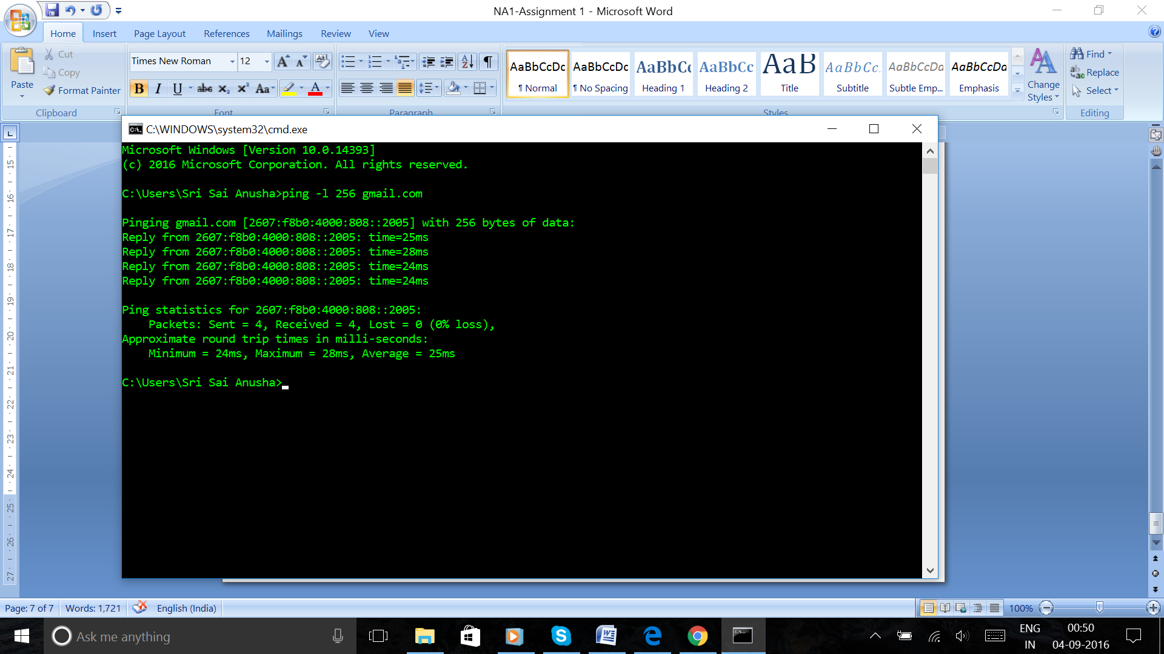

ping –a command resolves the addresses to the hostnames

**ping –a abc.com**

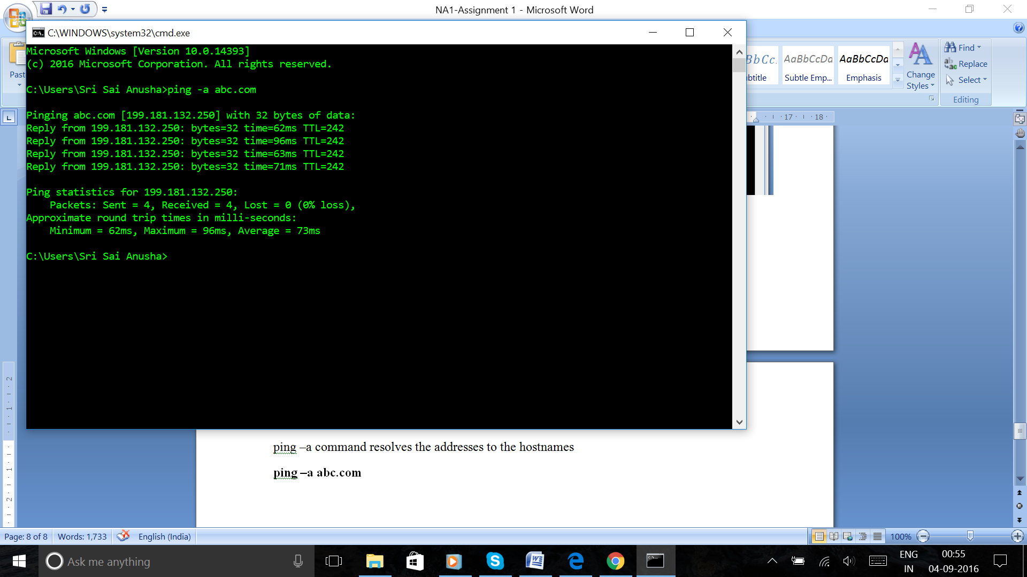

**ping –a makemytrip.com**

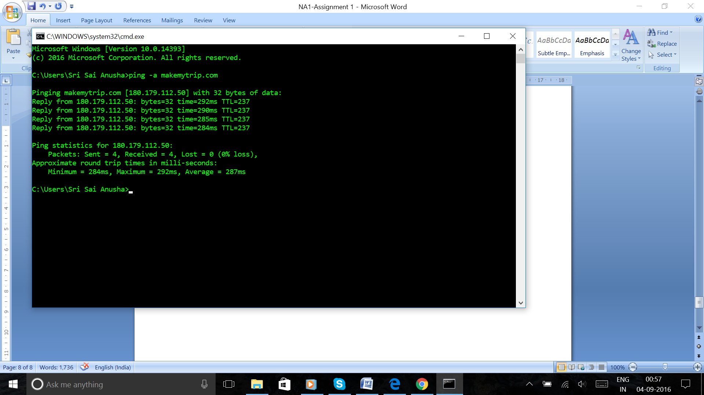

**Tracert:**

It is a path to display the route and measure transit delays of the packets across an IP network

tracert –h maximum hops command specifies the maximum number of hops to search for the target

**tracert –h 70 google.com**

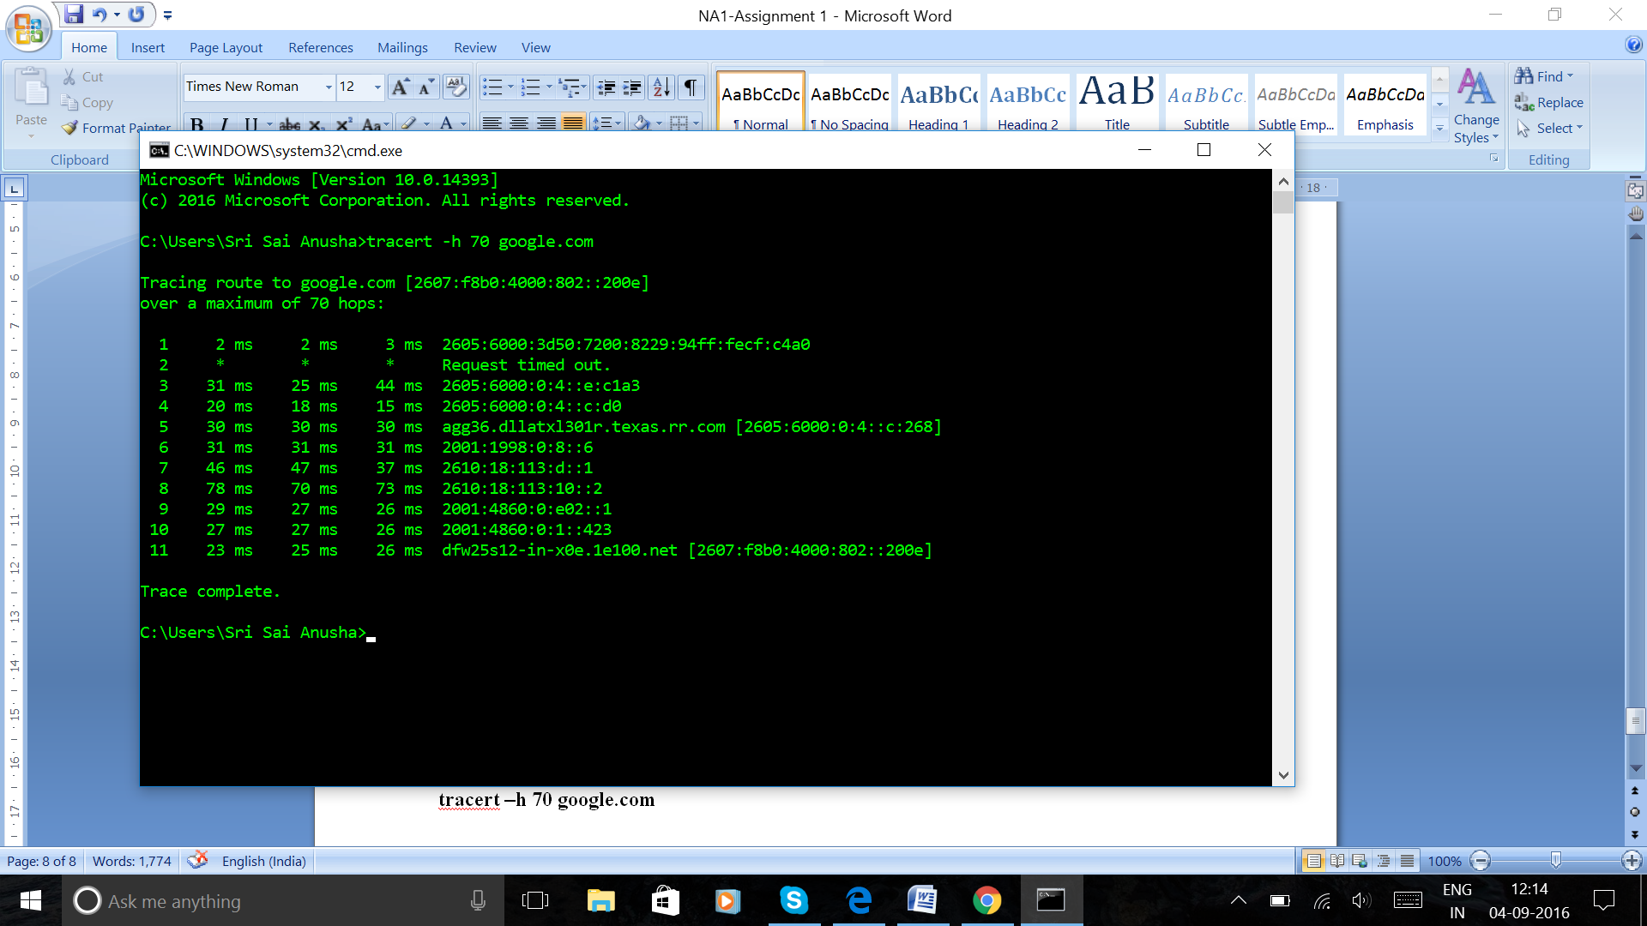

tracert –w timeout command waits the number of milliseconds specified for each reply

**tracert –w 1000 google.com**

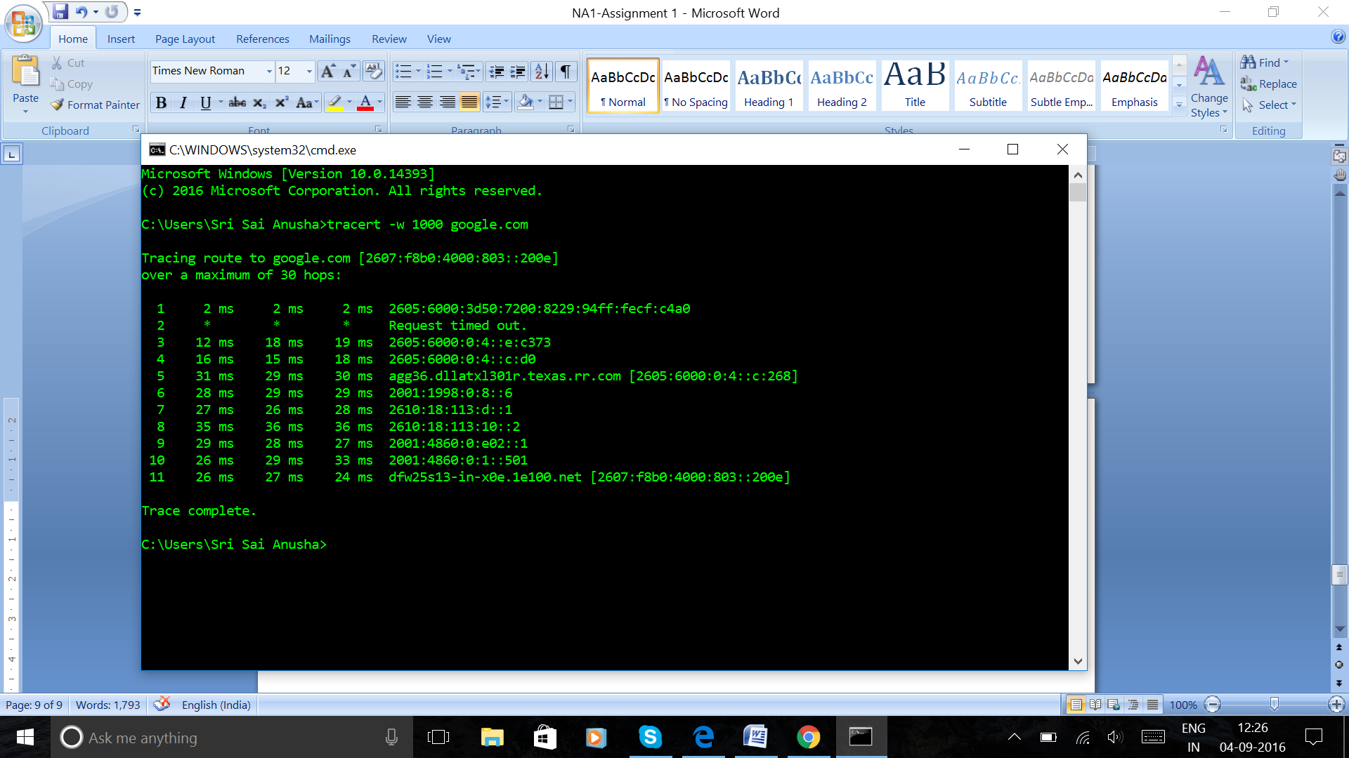

tracert –d command specifies to not resolve addresses to host names

**tracert –d google.com**

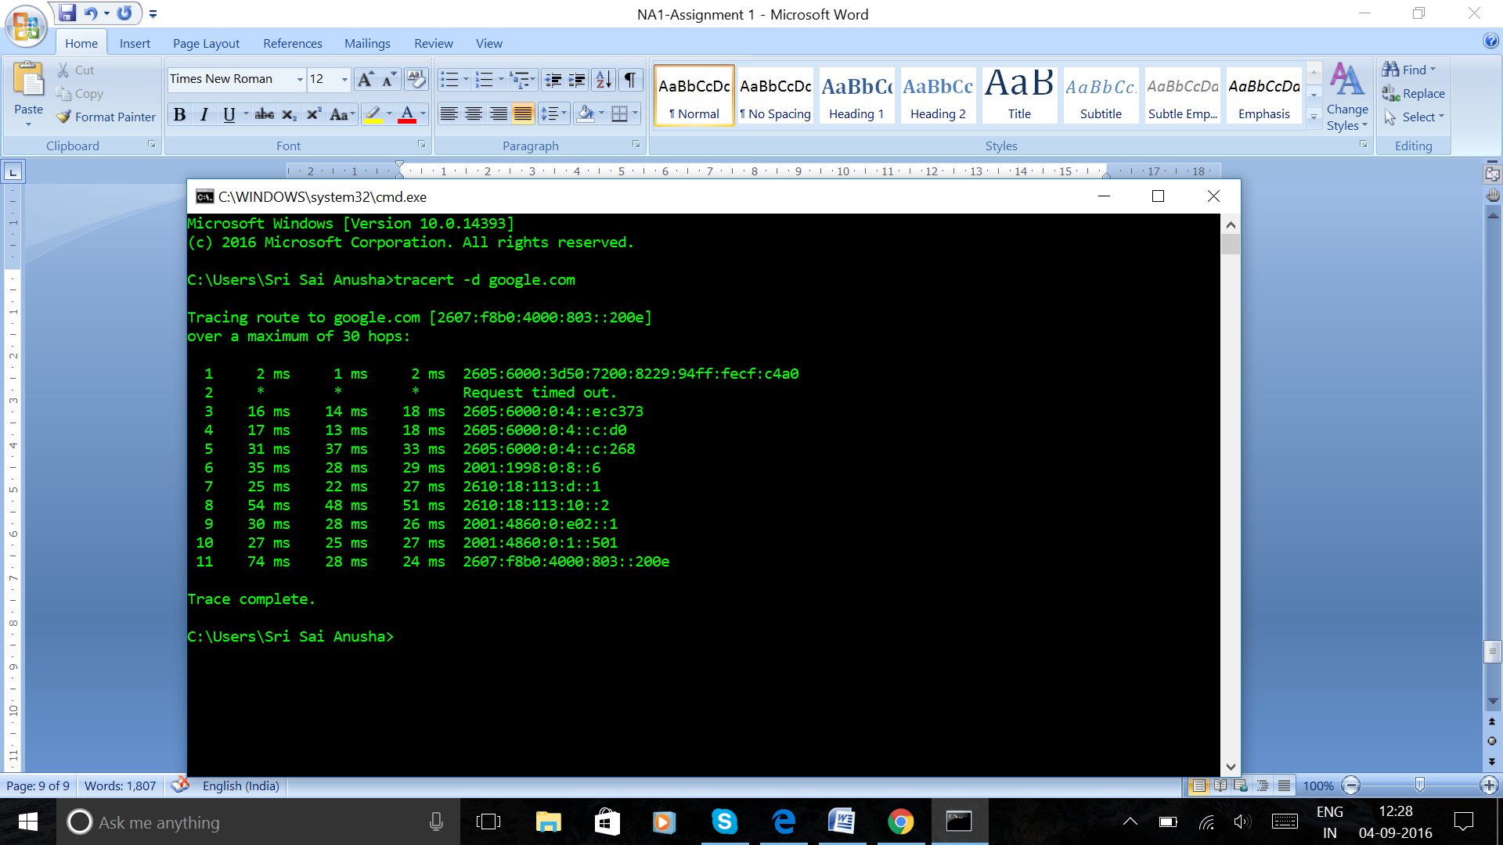

**5.** Explore ‘nslookup’ which is a program to query Internet domain name servers. Particularly, a. Find out the IP address (es) of www.yahoo.com. b. Find out the name servers and their IP addresses of yahoo.com domain. c. Find out the email servers and their IP addresses of yahoo.com domain. d. Try two other options (same server, different command parameters). Record the commands and their output.

**Ans:**

**nslookup:**

nslookup is a network administration command line tool that is used to obtain the Domain Name Server (DNS) and IP address mapping.

**a)**

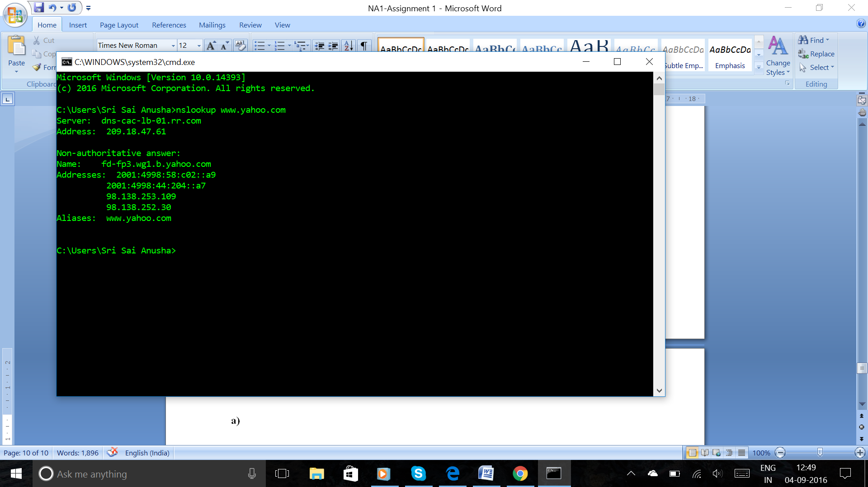

**b)**

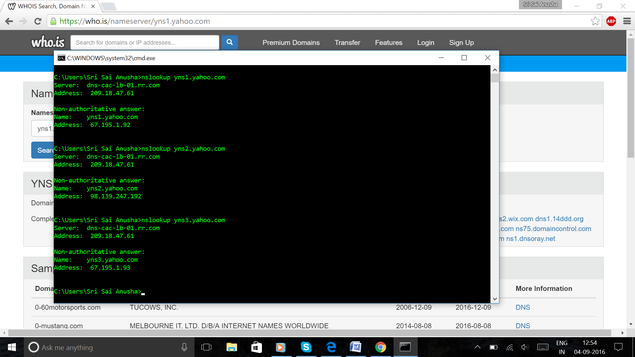

**c)**

Incoming mail (POP) server

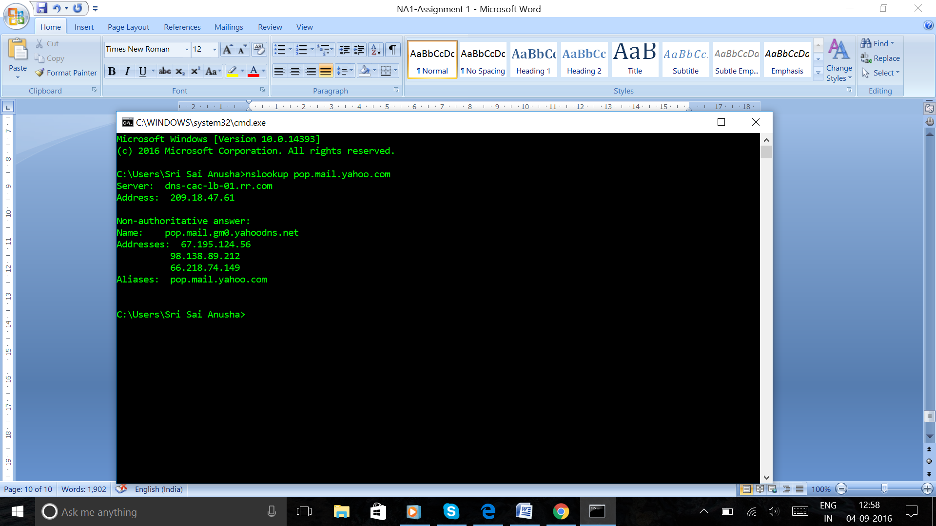

Outgoing mail (SMTP) server

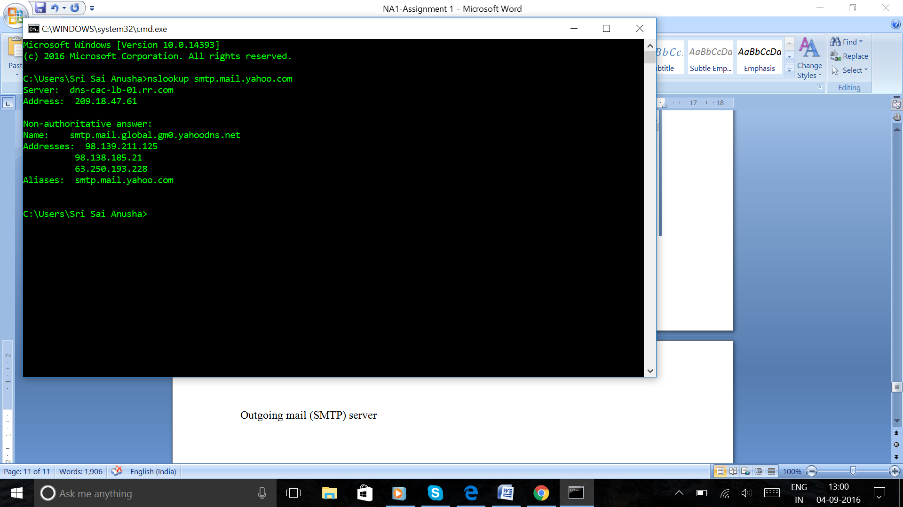

**d)**

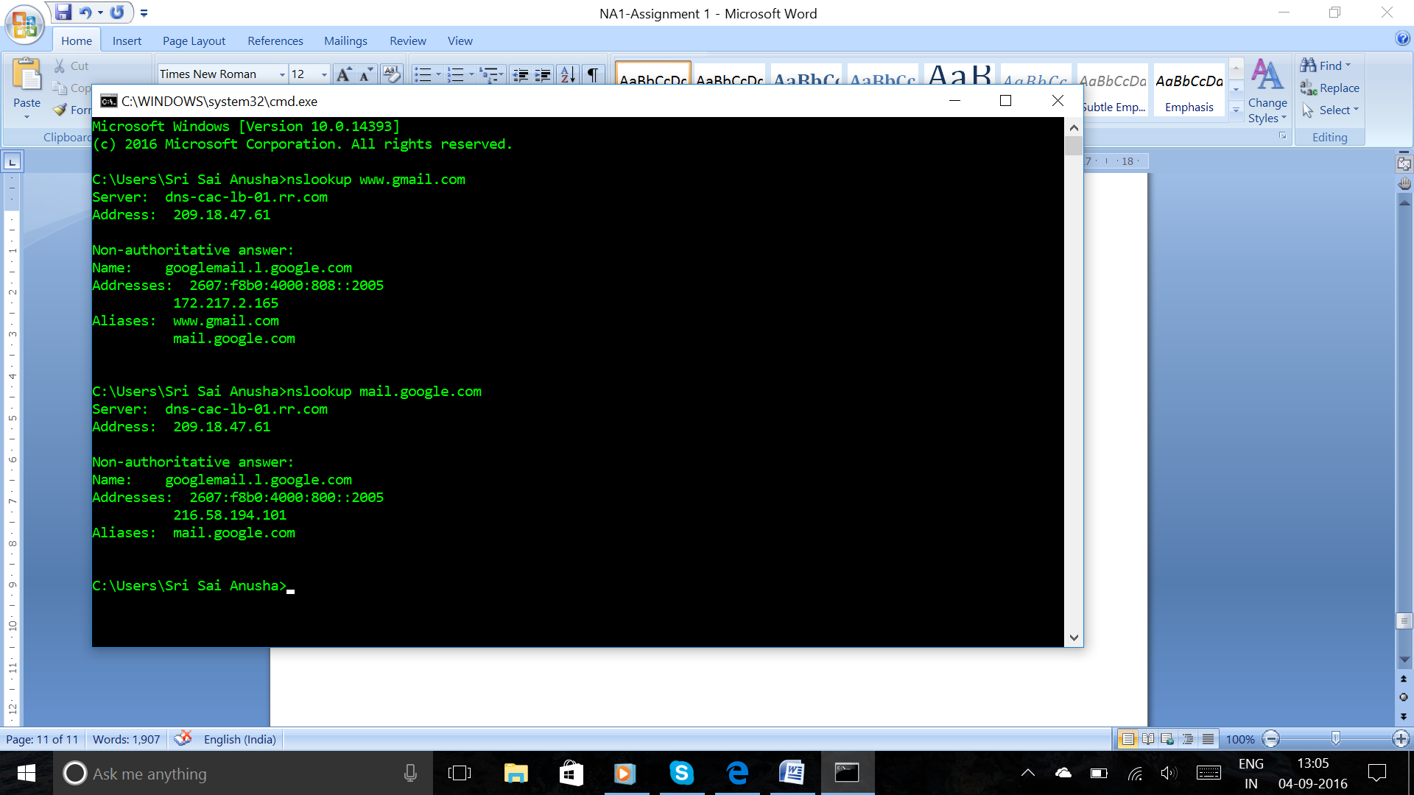

**6.** Explore IETF web page (www.ietf.org) and find out how many RFCs are there currently? Then, list at least 5 working groups. Among those working groups, choose one of them and summarize its activities in one page, i.e., objective of the charter, documents/issues published or discussed in the working group.

**Ans:**

IETF (Internet Engineering Task Force) is an open standards organization which has no membership requirements. It develops and promotes various Internet standards which comprise the Internet Protocol Suite (TCP/IP).

The mission of IETF is to make the Internet work better by producing high quality that influence the way people design, use and manage Internet.

RFC (Request for Comments) is a publication of IETF. They are the official documents of Internet specifications, communication protocols and procedures.

As of March 2016, there are 7700 RFCs.

Working Groups (WGs) in IETF are the primary mechanism for the development of specifications and guidelines. They are generally designed to address a specific problem.

WGs are classified as Active Working Groups and Concluded Working Groups.

The Areas in IETF include

1. Applications and Real Time Area
2. General Area
3. Internet Area
4. Operations and Management Area
5. Routing Area
6. Security Area
7. Transport Area

The Active Working Groups in Application and Real Time Area (ART) include

1. appsawg – ART Area General Applications Working Group
2. avtcore – Audio/Video Transport Core Maintenance
3. bfcpbis – Binary Floor Control Protocol Bis
4. cellar – Codec Encoding for LossLess Archiving and Realtime transmission
5. dbound – Domain Boundaries
6. ice – Interactive Connectivity Establishment
7. mmusic – Multiparty Multimedia Session Control
8. payload – Audio/Video Transport Payloads
9. slim – Selection of Language for Internet Media
10. webpush – Web-Based Push Notifications

**MMUSIC:**

The Multiparty Multimedia Session Control Working Group was chartered to develop protocols to support Internet teleconferencing and multimedia communications. The group negotiated media streams with the Session Description Protocol (SDP) which is used to express media and session descriptions. It also maintains Real Time Streaming Protocol (RTSP) specification.

The current aims of the working group include:

1. Provide SDP signaling support for the Interactive Connectivity   
   Establishment (ICE) protocol and its extensions. These were originally   
   defined in MMUSIC, but are now handled by the ICE WG.
2. Various other extensions to SDP may be pursued to remedy the most   
   urgent of SDP's shortcomings. These include updates to the SDP   
   specification itself and missing IANA registrations.

The documents issued by the group include:

1. MSRP over Data Channels
2. SDP based Data Channel Negotiation
3. A Session Initiation Protocol (SIP) usage for Trickle ICE